Harrisdale Primary School

Homework

Guidelines

Established 2017

Harrisdale Primary School

Homework Guidelines for Teachers

Rationale

The main focus of any meaningful homework should always be to support higher levels of student achievement by providing students with more opportunities and time to consolidate skills and concepts learned at school.

Homework can also further school-home relationships and can assist in keeping parents informed about the student’s learning program and progress. It should be noted that preparation of students for the time commitment of homework anticipated in years to come is not, in itself, a reasonable basis for setting homework.
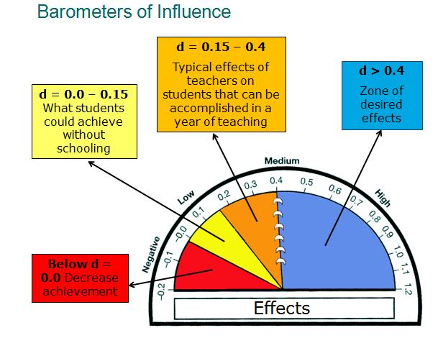
The research suggests that in the primary school years that homework has very little effect on student achievement. John Hattie’s research indicates that homework has an effect size of 0.29 on student learning. This is well below the desired effectiveness. For this reason homework needs to be clearly focused on consolidation of skills and development of good working routines.

Purpose

Homework is:

- Used to facilitate the support of learning outcomes
- Part of a developmental learning program that is responsive to individual needs, clearly relevant and supported by classroom practice
- Disassociated from any form of punishing students or means of securing discipline
- To support the development of the student’s independence as a learner
- To further the partnership between school and home
- To avoid dependence on unreasonable levels of parental assistance or resources that are not readily available to the student
- In the main it will consist of consolidation, completion of set tasks and research where appropriate.

Guidelines

- Parents may choose for their child to do far less homework than suggested, however this is to be done in consultation with the teacher.
- Preparation and organisational tasks in readiness for the next school day should be routine for all children. These tasks are included within the time allocation guidelines.
- Homework should only be completed from Monday to Thursday. Time allocations each night will be determined by the teachers based on the needs of the child, although should not exceed more than 30 minutes per night.
- Each teacher will have a particular system for collecting and providing feedback on homework that will be communicated to parents.
- Homework expectations grow as the students move into the senior years and become more independent learners. In the early years it is strictly about practicing the essential skills for learning and as the students develop we begin to add in skills to develop the whole child as well.

Harrisdale Homework Grid Model
Consensus of staff is that all year levels are able to employ some form of a Homework Grid to allocate and monitor homework. All Students from PP to Year 6 are expected to complete the minimum nightly activities each night. See the ‘Nightly Activities’ table below:

Nightly | Reading  Students are to read their home reader nightly for a minimum of 10 minutes until it is finished. Upon completion they are to read their library book, a novel from home, or the newspaper.  Parents need to sign or initial in the boxes each night the student reads: |  |  |  | Magic Words  Students are required to be able to read initially and them write all their words to progress.  Junior students simply need to read the words, whereas the senior students would need to write them and demonstrate they can use them in context. |  |  |  | Maths Focus  Students are to complete the following maths activities for the week:  - Basic Number Facts  - Mental Maths  - Mathletics  Study Ladder
Parent Initial | MON | TUE | WED | THUR | MON | TUE | WED | THUR | MON | TUE | WED | THUR
As students move through Early Childhood and into primary schooling years the expectations are raised gradually and teachers may opt to add additional activities that are completely either weekly or fortnightly. Please remember that these should be based on students learning experiences in the classroom or fundamental life skills and need regular and constant feedback.

Weekly Activities | Activity One: |  |  |  | Activity Two: |  |  |  | Activity Three:
 | Activity Four: |  |  |  | Activity Five: |  |  |  | Activity Six:
 | Activity Seven: |  |  |  | Activity Eight: |  |  |  | Activity Nine:
To support staff collaboration staff also have access to a Google Doc through which they can add ideas for all to share. This supports staff to work smarter not harder.
https://docs.google.com/a/harrisdaleps.wa.edu.au/document/d/1EGni9UoG_pgZ_kZTizAiqNojbWmO_yGHXfT1I-7dDuA/edit?usp=sharing

Individual classroom teachers will employ systems for monitoring and feedback that best suits the needs of their class. Wherever possible feedback should be given directly to students in timely and meaningful ways. It is also recommend that homework achievement is made visible in the classroom environment to connect student learning between school and home.

The following is a guide to the types of homework likely to be provided at Harrisdale Primary School. These focuses should be developed by classroom teachers and teams to create activities to fill out the grid.

Harrisdale Homework Expectations Guide

Pre-Primary

Reading to a Parent

Magic Words

Basic Number Facts

Year 1

Reading to a Parent

Magic Words

Basic Number Facts

Study Skills & Routines
Year 6

Independent Reading

Spelling Activities

Mental Maths Skills
& Concept Application

Concept Specific Tasks & Unfinished work

Year 5

Independent Reading

Spelling Activities

Mental Maths Skills
& Concept Application

Concept Specific Tasks & Unfinished work
Year 4

Reading to a Parent

Spelling Activities

Mental Maths Skills
& Concept Application

Year 3

Reading to a Parent

Magic Words
& Spelling

Mental Maths Skills

Year 2

Reading to a Parent

Magic Words
& Spelling

Mental Maths Skills

Kindy

Reading with a Parent
Maths
Reading Focus
Literacy

PLEASE NOTE: Each element within this guide would have a time allocation of 5 – 15 minutes depending on student developmental need. As an example PP student may only spend 5 minutes on Magic words, whereas a Year 6 Student may spend longer and it include some form of written application of words as well.

Shared Roles & Responsibilities for Homework

Responsibilities of the School/Teacher
In presenting homework the teacher should:
- Have homework well organised
- Advise students as clearly and accurately as possible, preferably in written form.
- Set clear and reasonable deadlines as to when the assignment / homework is due.
- Encourage a planned and responsible approach so that work is not done in a hurry at the end.
- Communicate incomplete or unattempted homework to the parents (telephone, email or sending home notes).
- Feedback should be purposeful and timely (within 1 to 2 days of being handed in).

Responsibilities of Students
- Make sure you clearly understand what has to be done, when is it due in and any other details
- If you were absent when homework was given out, it is up to you to find out (from friends or from your teacher) what you missed and do something about it.
- Communicate with your teacher if you have any difficulties or do not understand what has to be done.
- Organise your overall time for homework and study
- Keep a homework diary
- Make a genuine effort to complete all homework

Responsibility of Parents
We do know that there are sometimes difficulties facing parents when it comes to helping students. However, very valuable help can be given by:
- Children need the opportunity to play and relax after school.
- Set up a homework survival kit, does your child have all he/she needs to complete hi/her assignments? Or do they waste time searching for pencils etc.
- Homework is best done at a quiet time set aside for homework completion.
- Completing homework in front of the television is not recommended.
- Ask your child to explain what he/she is doing for homework.
- Praise your child. It is easy to criticise your child when homework is not done. It is a lot harder to give applause for homework completed. It is important to remember that your words of praise, more than anything else, will motivate your child to do his/her best. “A Parent’s Role is not Teacher; it is Coach and Cheer Squad.”

Conclusion
Homework should be a positive experience for children and parents, aimed at building work ethic and enhancing the extent to which a child benefits from the real life learning and the school’s learning experience

